1st Preparatory
Study this Project for the Computer Practical Exam:
1- Open GIMP2
2- To show the “Tool Options” and “Layers” tabs:
From “Windows” menu, select “Dockable Dialogs” then choose “Tool Options” or “Layers”.
3- From “File” menu, select “New”.
4- Fill the background layer of foreground colors with the “Bucket Fill Tool” from the “Toolbox”.
5- Draw on the background layer using the “Paintbrush Tool”, change its color, shape and size before drawing.
6- From “File” menu, select “Open as Layer” to open an image as a new layer.
7- Use the “Scale Tool” to change the dimensions of the image, then click on the “Scale” button from the scale information dialog box.
8- Use the “Move Tool” to move the new image on the background.
9- To be able to cut or delete a part of the new image layer:
- Make sure that there is no selection: from “Select” menu, choose “None”.
- On the “Layer” tab, press right click on the image layer and select “Add Alfa Channel” from the drop down list.
10- Use the “Fuzzy Select Tool” to select the area of the current image based on color similarity then click on “Delete” from the keyboard.
11- To merge all the layers of the image into a single layer: From “Image” menu, select “Flatten Image”.

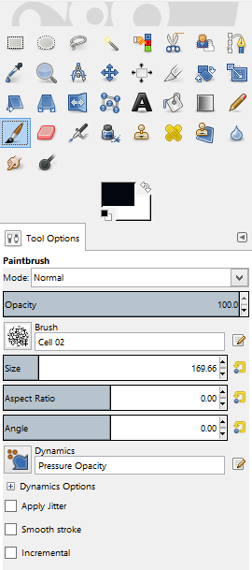
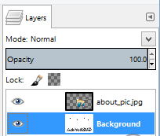
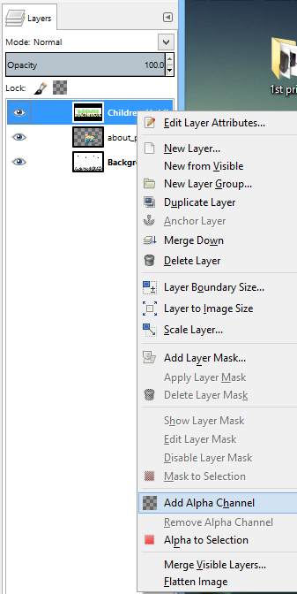
Menu bar
Layers tab
The Toolbox
Tool Options Tab:
To change the shape and the size of the paintbrush tool

“Add Alfa Channel” option

